BA700 Winter 2021

Project 1 (20%)

Due February 21, 10PM

Upload a single SQL Query Script containing all of the responses to the questions below. Be sure to comment to denote each question (i.e., /*Question 1*/)

Insert a screenshot of your result set panel and action panel for each of the following questions.

Example submission:

**Use employee_master to complete the following:**

**Question 1 (2 points)**

Write a query that does the following:

1. Includes the columns Employee_ID, Employee_Name, Employee_Hire_Date, Salary, City, Department, and Job_Title.
2. Filters the rows to include only employees from Australia (AU) who have salaries less than $100,000.

c. Sorts the data by ascending employee name.

select Employee_ID, Employee_Name, Employee_Hire_Date, Salary, City, Department, job_Title, Salary, Country

from project1.employee_master

where Country = 'AU'

HAVING (Salary)<=100000

order by Employee_Name;

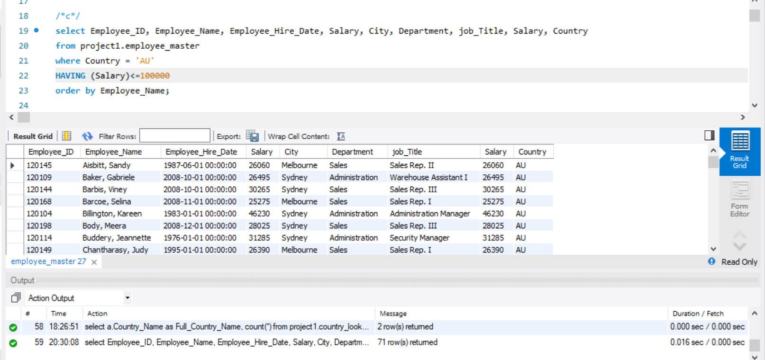

**Question 2 (2 points)**

Generate a list of departments and the number of employees within each department. Sort by the number of employees within department.

SELECT Department, COUNT(*) as Emp_Num

FROM Project1.employee_master

GROUP BY Department

order by Emp_Num;

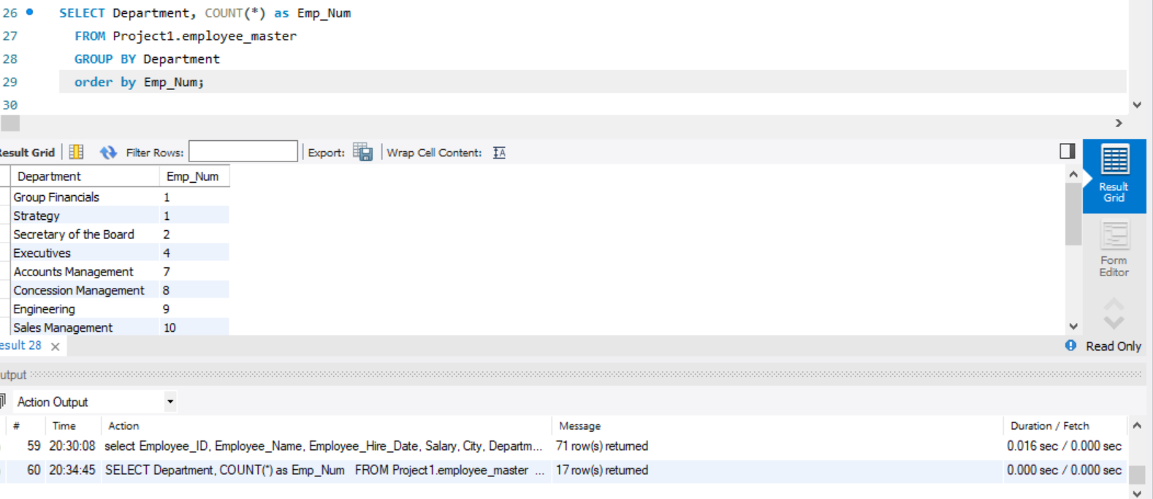

**Question 3 (2 points)**

Write a query that includes the department and creates three calculated columns calculating the mean, minimum, maximum **Salary** for each department. Sort by department.

SELECT Department, AVG(Salary), MAX(Salary), MIN(Salary)

from project1.employee_master

group by Department

order by Department;

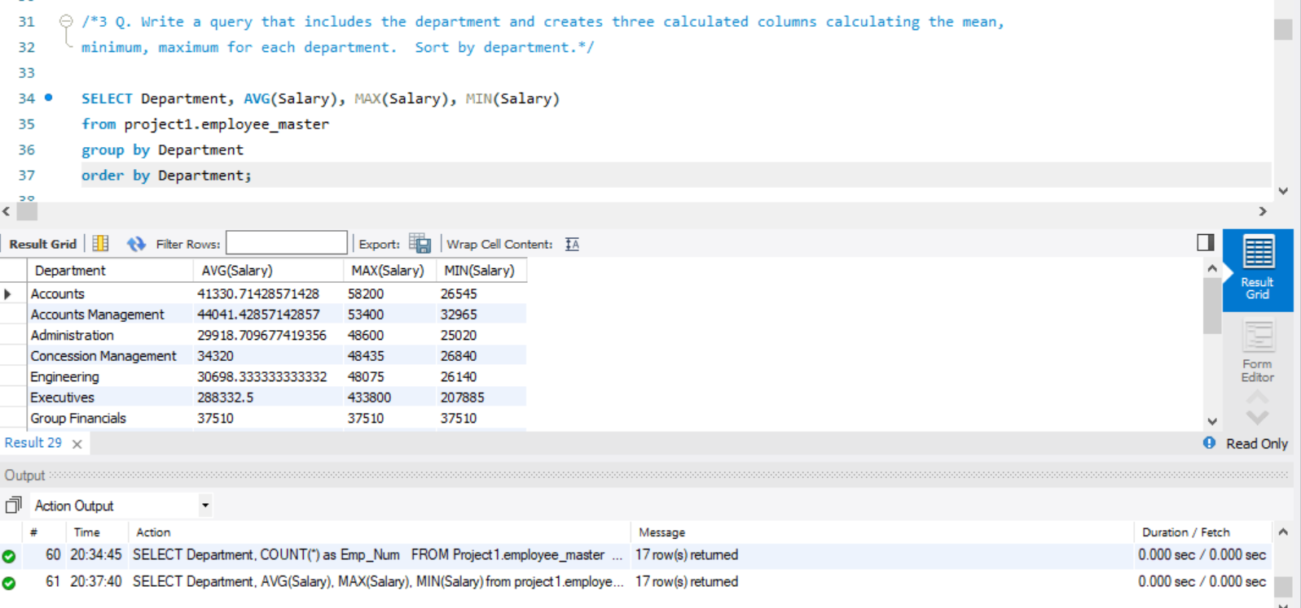

**Question 4 (2 points)**

Write a query that includes all columns and contains all employees with the word Sales as part of their job titles. Sort the results by department and job title.

select Job_Title, Department

from project1.employee_master

where Job_title like '%Sales%'

order by Department;

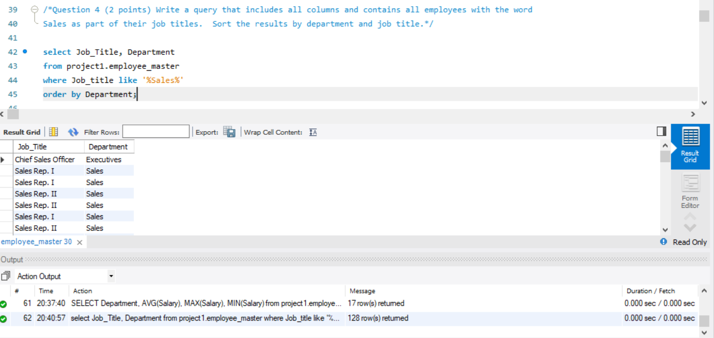

**Question 6 (5 points)**

Write a query that does the following:

a. IncludesDepartment and the appropriate calculated columns

b. Calculate the number of employees, the average salary, and the total salary for each department.

c. Filter the query to include only those departments with more than 10 employees.

d. Sort the data by decreasing department size, based on the number of employees.

SELECT

Department, COUNT(*), AVG(Salary), SUM(Salary) total_salary

FROM

project1.employee_master

group by Department

having count(*) >10

order by count(*) desc;

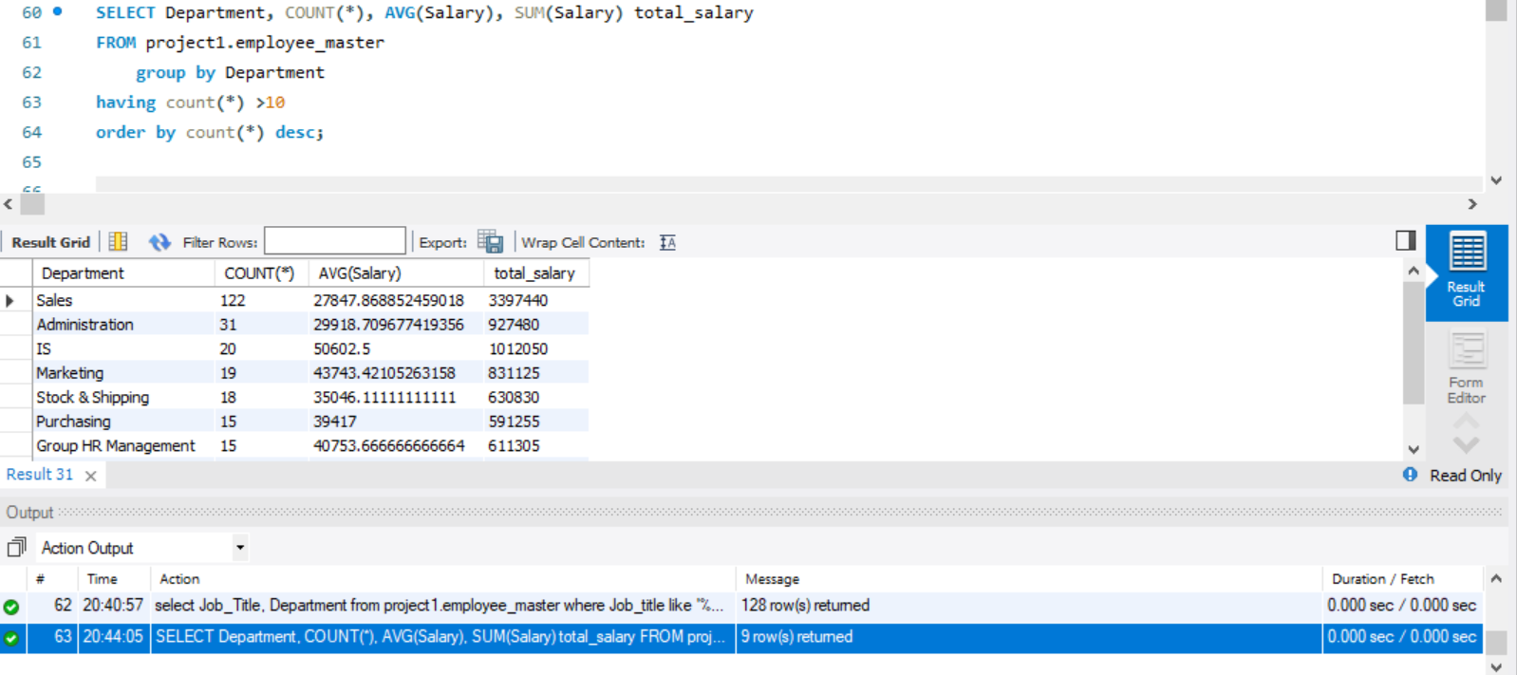

**Use the employee_addresses table to complete the following:**

**Question 7 (2 points)**

Write a query that includes Employee_ID, Employee_Name, Street_Number, Street_Name, and Postal_Code. Only include only those employees who have a Postal_Code value that begins with the characters 920.Order the output table in ascending postal code order.

select Employee_ID, Employee_Name, Street_Number, Street_Name, Postal_Code

from project1.employee_addresses

where Postal_Code like '%920%'

order by Postal_Code;

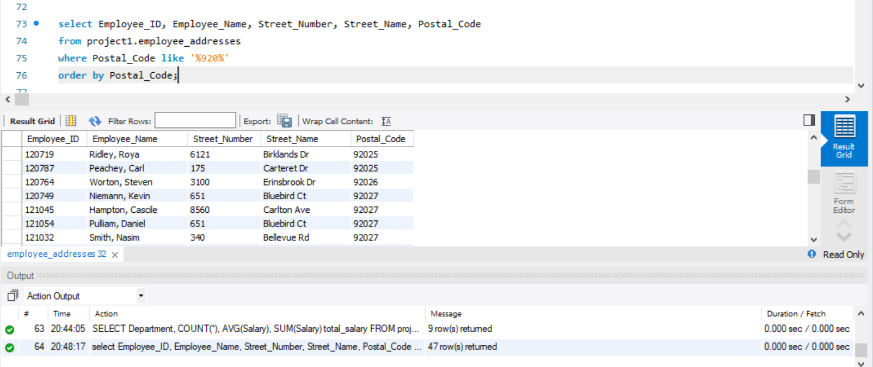

**Use the employee_payroll table to complete the following:**

**Question 8 (2 points)**

Write a query that containsEmployee_ID and Birth_Date columns. Only include employees with an October birthday.

select Employee_ID, Birth_Date

from project1.employee_payroll

where Birth_Date like '____-10-__ 00:00:00';

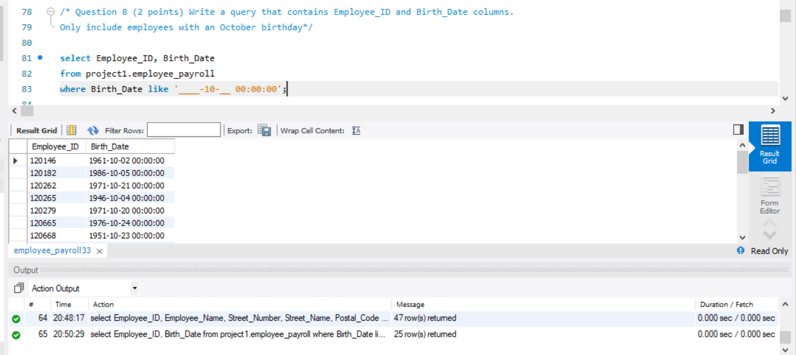

**Question 9 (3 points)**

Write a query that does the following:

a. Includes Employee_ID, Employee_Gender, Salary, Birth_Date, and Employee_Hire_Date.

b. Modify the properties of the Salary column to change the column name to Old_Salary.

c. Include only active employees who have a missing value for Employee_Term_Date.

d. Create a new column named New_Salary that is the current salary plus a 2% raise.

select Employee_ID, Employee_Gender, Birth_Date, Employee_Hire_Date, Employee_Term_Date, Salary as old_Salary,

Salary*1.02 as New_Salary

from project1.employee_payroll

where Employee_Term_Date like ''

order by Employee_ID;

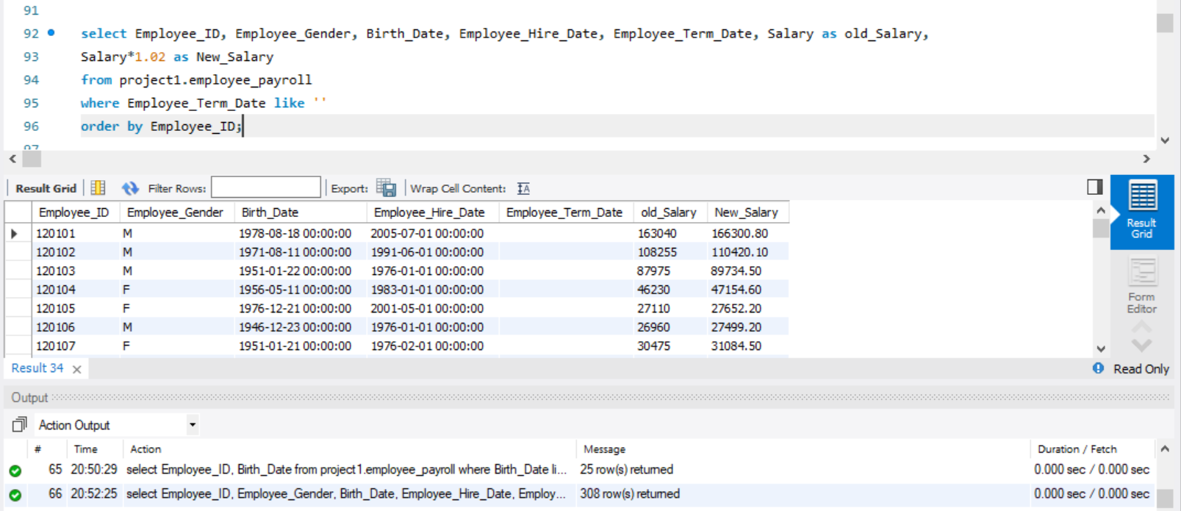

**Question 10 (3 points)**

Write a query that does the following:

a. Includes Employee_ID and Employee_Hire_Date.

b. Onlyincludes employees without a termination date.

c. Creates a new column named Years_Employed that calculates the number of years that each employee has worked at the company, based on the hire date and today's date.

SELECT Employee_ID, Employee_Hire_Date, datediff(Current_date(), Employee_Hire_Date)/365

from project1.employee_payroll

where Employee_Term_Date like ''

order by Employee_ID;

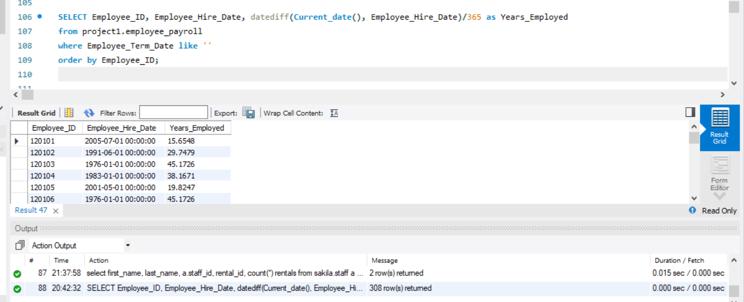

**Complete the following two join queries:**

**Question 11 (5 points)**

Join employee_payroll and employee_addresses on the Employee_ID column.

a. Include the following columns Employee_ID, Employee_Name, Employee_Gender, Birth_Date, Salary, Street_Number, Street_Name, City, State,

and Country.

b. Create a new column named Bonus that represents 1.5% of the Salary column.

c. Include only active employees in the output table, or those that do not have a value for Employee_Term_Date.

SELECT a.Employee_ID, a.Employee_Name, a.Street_Number, a.Street_Name, a.City, a.State, a.Country, b.Employee_Gender, b.Salary, b.Birth_Date,

salary*1.5/100 as new_salary

from project1.employee_addresses a

inner join project1.employee_payroll b

on a.Employee_ID = b.Employee_ID

where Employee_Term_Date like ''

order by Employee_ID;

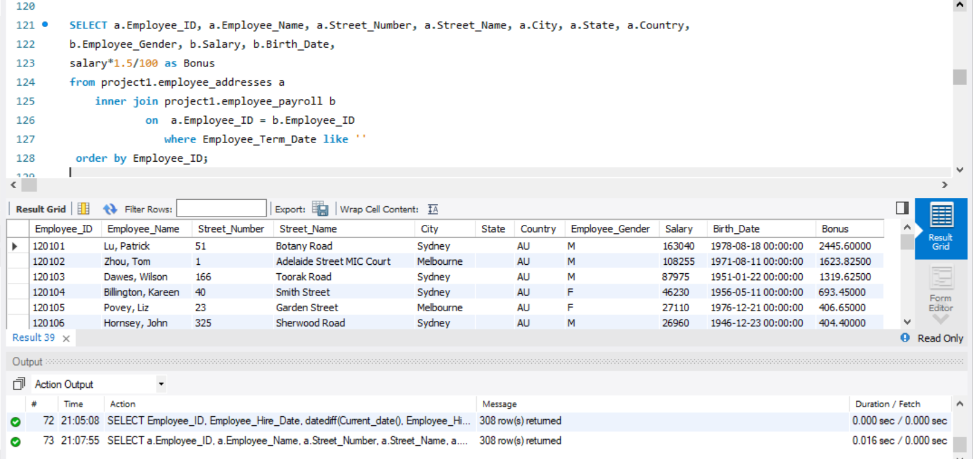

**Question 12 (4 points)**

Create a new query that adds country_lookupto the above join.

a. Join country_lookup and employee_addresses by the common column. Note, The common column might be named differently in the two tables.

b. Remove the country column from the above query replace it with a column representing the full country name in the country_lookup table.

select a.Country_Name as Full_Country_Name, Country_Key

from project1.country_lookup a

inner join project1.employee_addresses b

on a.Country_Key = b.Country

group by Country_Name;

